**Topics: Normal distribution, Functions of Random Variables**

1. The time required for servicing transmissions is normally distributed with *μ* = 45 minutes and *σ* = 8 minutes. The service manager plans to have work begin on the transmission of a customer’s car 10 minutes after the car is dropped off and the customer is told that the car will be ready within 1 hour from drop-off. What is the probability that the service manager cannot meet his commitment?
2. 0.3875
3. 0.2676
4. 0.5
5. 0.6987

Ans) we have normal distribution with mean = 45 and std.deciati on = 8

Let “X” be the time required to complete the repair of a car .

To finish in one hour you must have X<= 50( ie 60-10)

So the question is to find the P(X>50)

P(X <= 50) = P(Z <+ (50-45)/80) = p(Z <= 0.625) = 73.4%

probability that the service manager cannot meet his commitment will be 100-73.4

**=26.6% or 0.2676**

1. The current age (in years) of 400 clerical employees at an insurance claims processing center is normally distributed with mean *μ* = 38 and Standard deviation *σ* =6. For each statement below, please specify True/False. If false, briefly explain why.
2. More employees at the processing center are older than 44 than between 38 and 44.

Ans) probability of employees having age between 38 and 44 is more than employees

older than 44. Thus the statement is false.

1. A training program for employees under the age of 30 at the center would be expected to attract about 36 employees.

Ans) Probability of employees less than age of 30 = P(X<30)

Z=(X- *μ* )/ *σ* = (30-38)/6

Thus the question can be solved using normal table

P(X <= 30) = P(Z <=(30-38)/6) = P(Z<= - 1.3333) = 9.12%

So the number of employees with the probability 0.912 of them being under age

30 = 0.912*400

= 36.48 or 36 employees

**Therefore the statement is True.**

1. If *X1* ~ *N*(μ, σ2) and *X*2 ~ *N*(μ, σ2) are *iid* normal random variables, then what is the difference between 2 *X*1 and *X*1 + *X*2? Discuss both their distributions and parameters.

Ans) 2X1 is the larger scaled version of the random variable X2.

If X1 is normally distributed then X2 is also normally distributed.

As given X1 and X2 follows normal distribution the associate sum also follows normal

distribution with appropriate parameters.

1. Let X ~ N(100, 202). Find two values, *a* and *b*, symmetric about the mean, such that the probability of the random variable taking a value between them is 0.99.
2. 90.5, 105.9
3. 80.2, 119.8
4. 22, 78
5. 48.5, 151.5
6. 90.1, 109.9

Ans) Since we need to find out the values of a and b , which are symmetrical about the

mean, Such that the probability of random variable taking a value between them is 0.99.

The probability of getting value a and b are 0.99.

So the probability of not getting a and b will be 1-0.99 = 0.01.

The probability towards the left from a = 0.01/2 = 0.005.

The probability towards the right from b = 0.01/2 = 0.005.

Since we have the probabilities of a and b we need to calculate X.

By finding the standard normal value of Z ,we can calculate X.

Z =(X- *μ* )/ *σ*

Z value of 0.005 = -2.57

X=- Z\**σ* +*μ*

Z(-0.005)*20+100= -(-2.57)*20+100 = **151.4.**

Z(+0.005)*20+100 = (-2.57)*20+100 = **48.6.**

So option **D** is the correct answer.

1. Consider a company that has two different divisions. The annual profits from the two divisions are independent and have distributions Profit1 ~ N(5, 32) and Profit2 ~ N(7, 42) respectively. Both the profits are in $ Million. Answer the following questions about the total profit of the company in Rupees. Assume that $1 = Rs. 45
2. Specify a Rupee range (centered on the mean) such that it contains 95% probability for the annual profit of the company.
3. Specify the 5th percentile of profit (in Rupees) for the company
4. Which of the two divisions has a larger probability of making a loss in a given year?

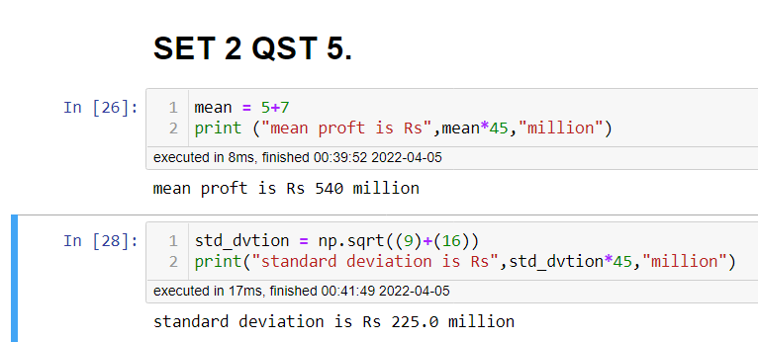

Ans)

1. A. Specify a Rupee range (centered on the mean) such that it contains 95% probability for the annual profit of the company.

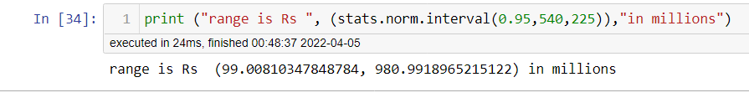

1. 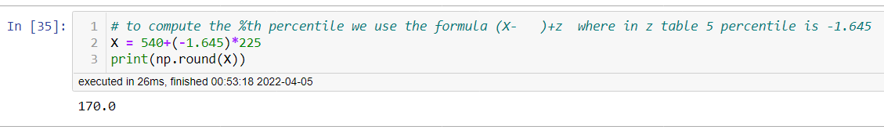Specify the 5th percentile of profit (in Rupees) for the company.